INSURANCE PREMIUM PREDICTION

WIREFRAME DOCUMENT

Chandan Kumar iNeuron

Homepage

Homepage consists of single page having different section to go on. The page designed in such way that user can switch between Home page, view logs ,view Artifact, View trained models ,Estimate Insurance Premium price prediction and train insurance premium model . There are 5 different sections in the homepage where the user can switch according to requirement.

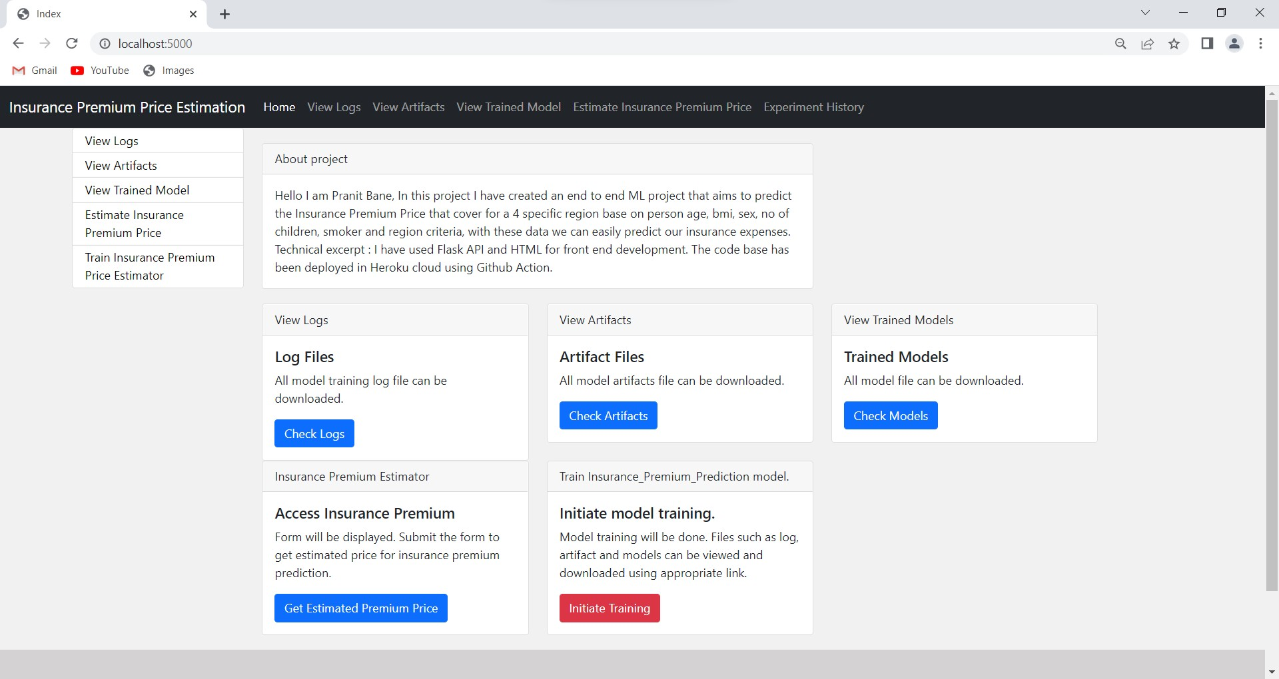

After Clicking on Train Insurance Premium Price Estimator:

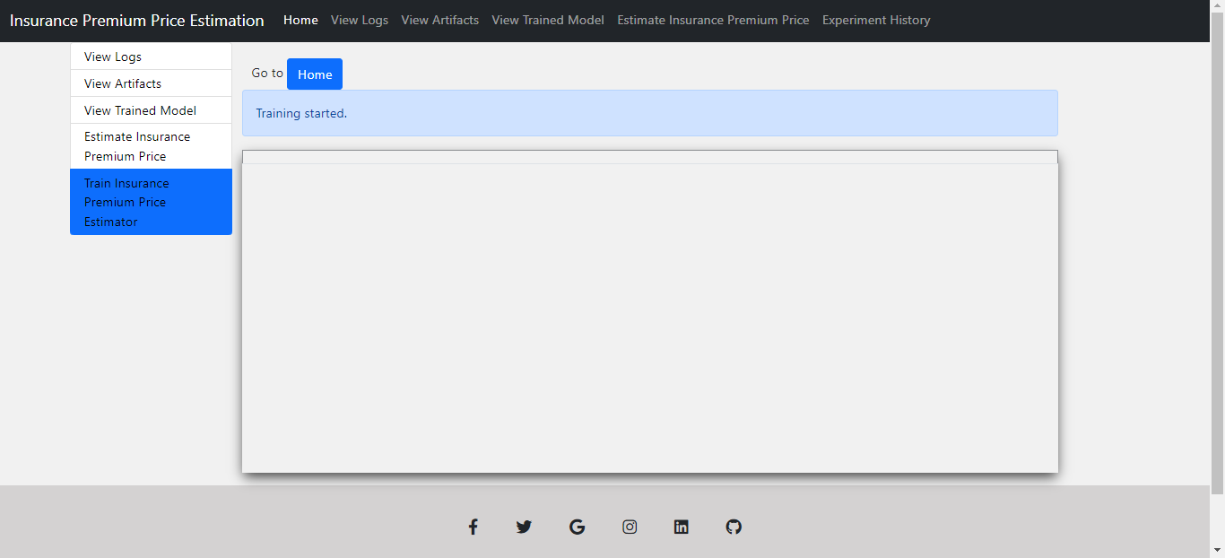

After clicking on that our model training will start and it will show the result in our experiment section .

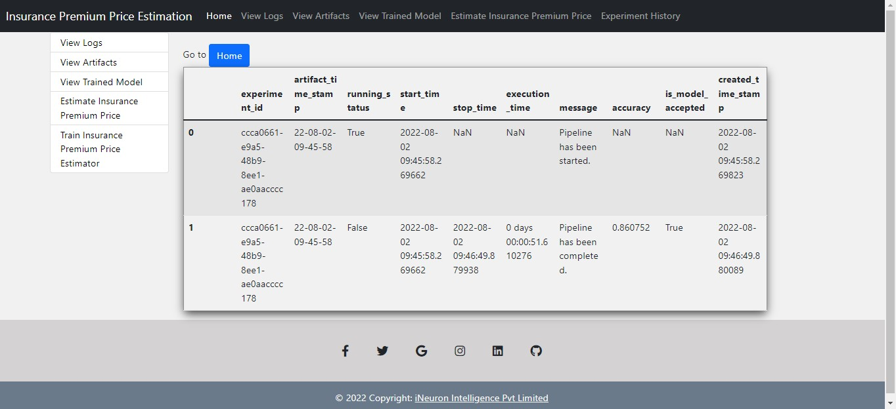

After our model trained successfully, we can start prediction while clicking on Estimate Insurance Premium Price Section

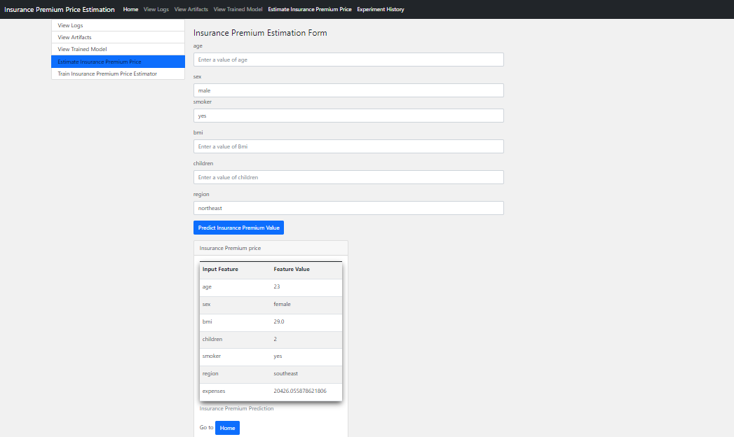

Fill the form for prediction and submit it for prediction.

We can also check our other components of our model such as artifacts, trained models, log history and experiement records

View Logs

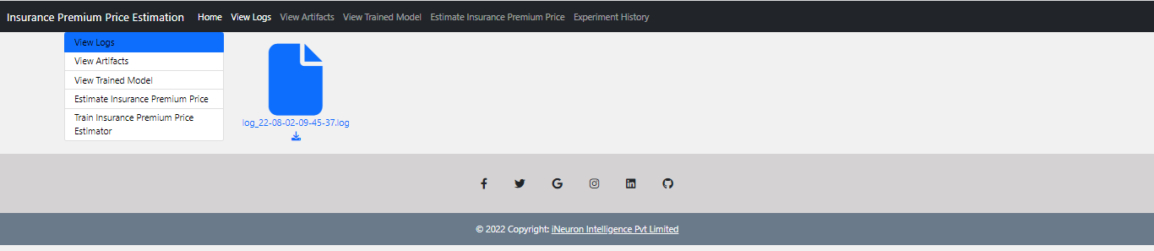

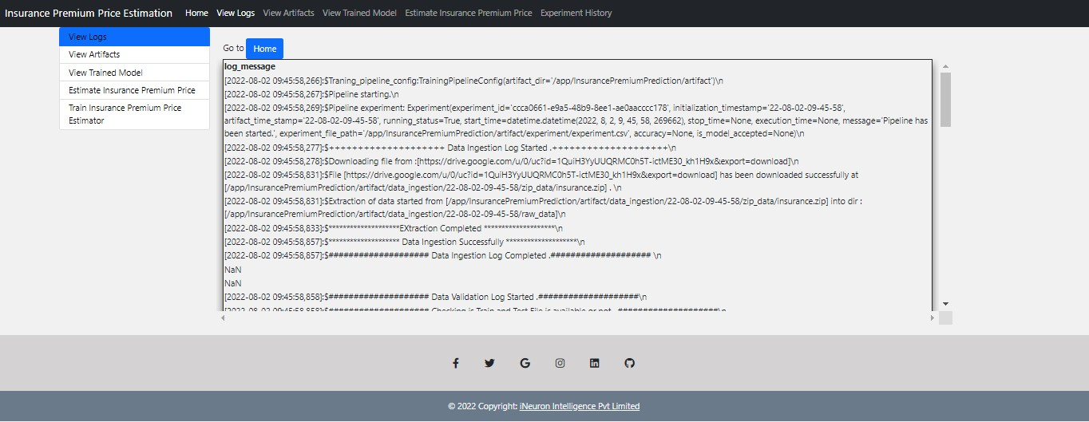

View Trained Models

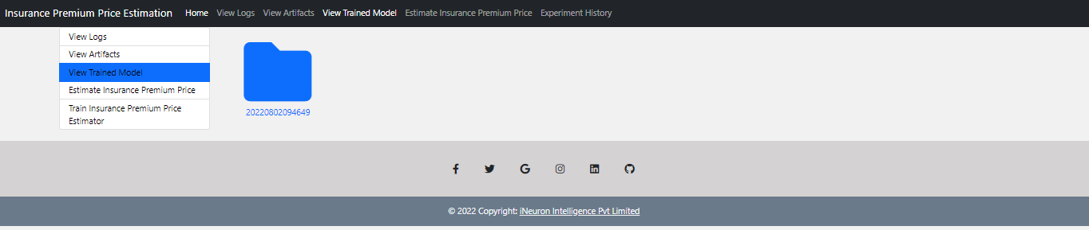

View Artifacts

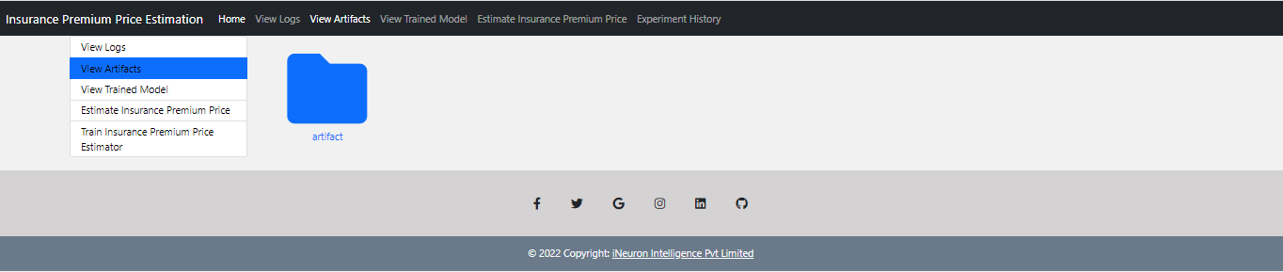

After further clicking artifact folder we can access all folders inside Artifacts

